Maryland Community College and University
Nursing Faculty Job Fair
Sponsored by Maryland Higher Education Commission (MHEC) and the Nurse Support Program II (NSP II)

Free to all interested Registered Nurses!

Meet nursing representative from Maryland academic institutions
Gain information about the Nurse Faculty Role
Learn more about Maryland’s Graduate Nursing Faculty Scholarship Service
Light Dinner Served
Monday, October 1, 2018; 4:00 pm – 6:00 pm
Charles I. Ecker Business Training Center, Room 6,
6751 Columbia Gateway Dr. Columbia, MD 21046

For More Information, contact Beth Batturs Martin, Nursing Director, Anne Arundel CC
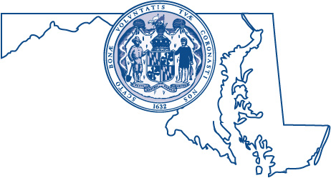
babatturs@aacc.edu
RSVP by September 24th: babatturs@aacc.edu

Health Services Cost Review Commission Nurse Support Program II
4160 Patterson Ave. Baltimore, MD 21215

