Faculty Instructions to Create an Account and Log In

Create an account (first time users)
- Go to URL: https://jhu.mediashareiq.com/

- Click Create Account
- Enter the following information to sign up for a new account
- First name, Last name
- Email
- Password, Confirm Password
- Role = Faculty
Note: All newly created passwords must include at least 6 characters with at least one lower case letter, one upper case letter, one number and one special character.
- You will receive an email to activate your account, directing your to https://jhu.mediashareiq.com/

Log into your account

- Go to https://jhu.mediashareiq.com/
Click Login and insert your
- Email
- Password

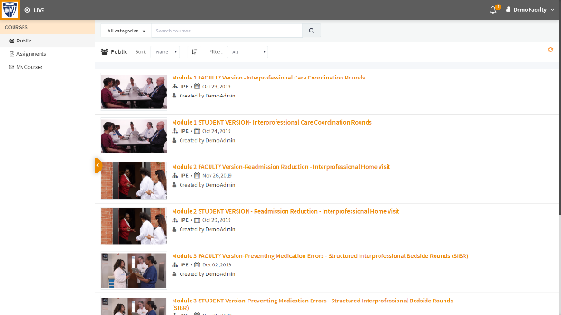
- Four IPE Simulation modules for virtual clinical experiences are provided. Each module has Faculty and Student Learner versions. Select the module you intend to use and notify your students with instructions for creating an account and logging in, as well as the title of the module which they will be using. Click the module to begin.

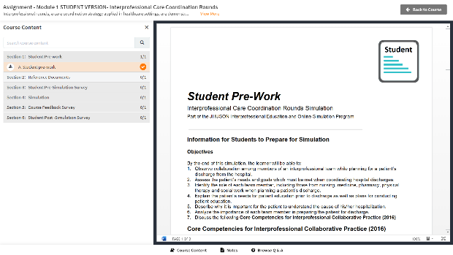
- Each module has several sections: Student Pre-work, Reference Documents, Pre-Simulation Survey, Simulation Video, Course Feedback and Post-Simulation Survey. NOTE: There are specific suggested instructions for using the module located under the Faculty Resources tab, including student pre-work and student clinical learning objectives.

