Maryland Community College and University
Nursing Faculty Job Fair
Sponsored by Maryland Higher Education Commission (MHEC) and the Nurse Support Program II (NSP II)

Free to all interested Registered Nurses!

Meet nursing representatives from Maryland academic institutions
Gain information about the Nurse Faculty Role
Learn more about Maryland’s Graduate Nursing Faculty Scholarship Service
Light Dinner Served
Wednesday, October 2, 2019; 4:30 pm – 6:30 pm
Harford Community College Darlington Hall
401 Thomas Run Rd, Bel Air, MD 21015

For More Information, contact Nancy Perry, Nursing Program Director, Carroll Community College
RSVP by September 23, 2019: nperry@carrollcc.edu
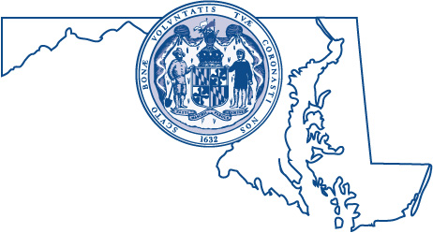  Health Services Cost Review Commission  4160 Patterson Ave. Baltimore, MD 21215 | Nurse Support Program II  6 N. Liberty St.  Baltimore, MD 21201

