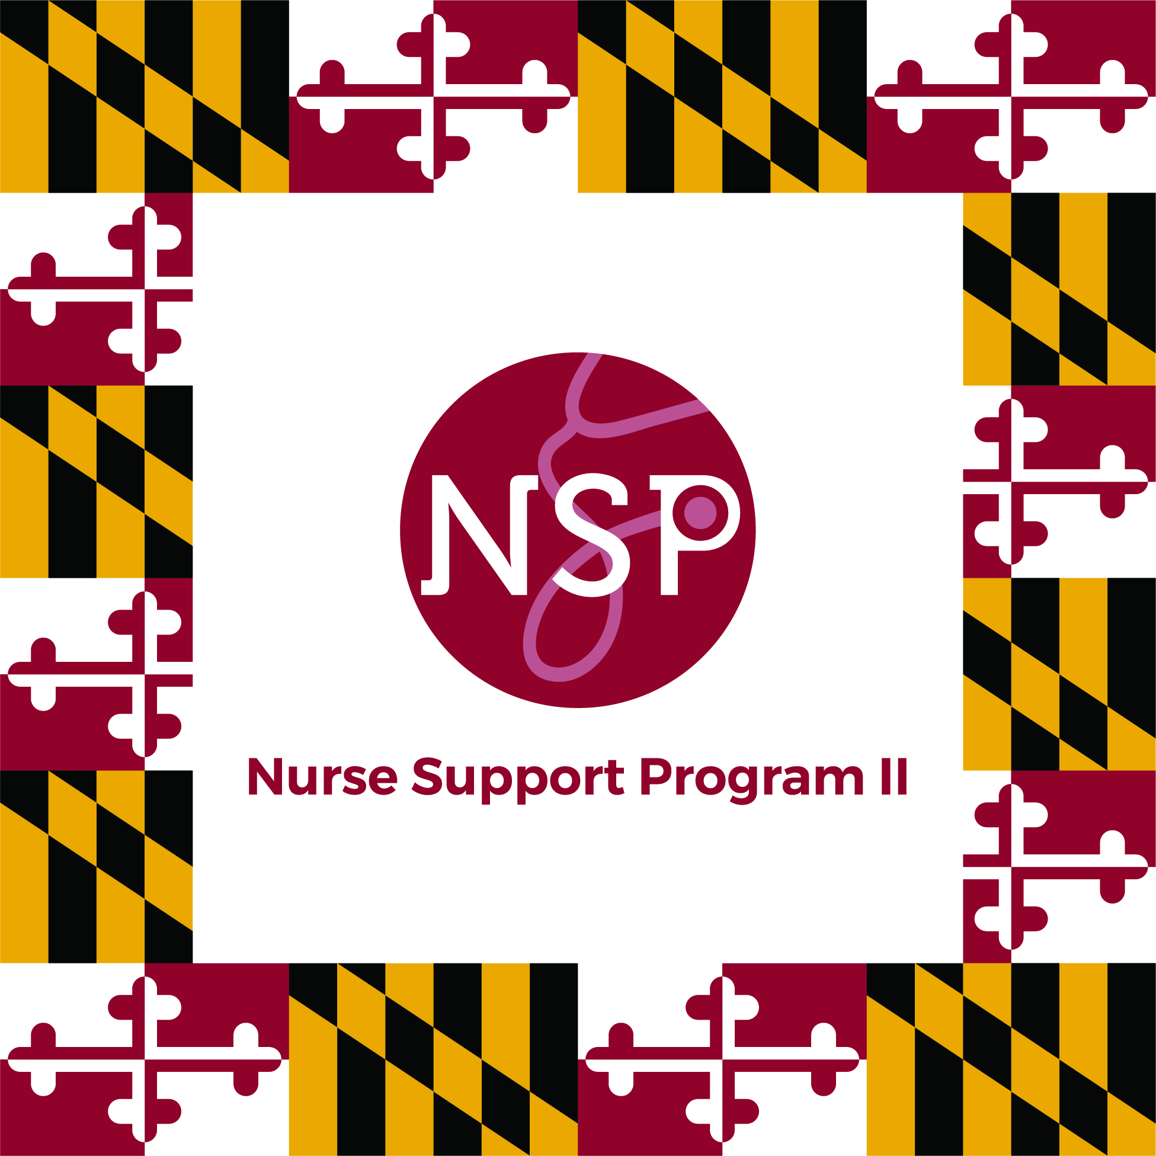  Doctoral EDUCATiON FOR NURSE FACULTY IN MARYLAND #4  Tuesday, May 4, 2021  4:00 - 5:00 PM  Presentations from Doctoral programs in Maryland:  - Coppin State University  Dr. Joan Tilghman, Ph.D. RN, CRNP, WHNP-BC, CNE  Chairperson DNP program  - Johns Hopkins School of Nursing  Dr. Kimberly McIltrot, DNP, CPNP, CWOCN, CNE, FAANP, FAAN  DNP Program Director  - Salisbury University  Dr. Annette Barnes, DNP, CRNP, FNP-BC, CNE  Graduate Program Chair  - University of Maryland School of Nursing  Dr. Shannon Idzik, DNP, ANP-BC, FAAN, FAANP  Associate Dean for Doctor of Nursing Practice Program | This annual event is for faculty interested in Doctoral Education. The focus of the next Doctoral Education Summit #4 is the Doctor of Nursing Practice (DNP). The event will be held virtually, hosted and moderated by Nurse Support Program II staff.  ────  An overview of the 4 instate DNP programs in Maryland will be presented to interested faculty and clinical educators at nursing programs and hospitals to answer important questions in choosing a program.  _____  This workshop will:  Summarize the current openings and options for DNP programs in Maryland  · Compare and contrast DNP concentrations and delivery formats.  · Identify issues to consider in choosing a program including financial support  · Provide 20 minutes for attendees to participate in a live Q and A session with presenters.  For more information and an event registration form, contact Dr. Peg Daw & Kim Ford at peggy.daw@maryland.gov & kimberly.ford@maryland.gov.

