Palliative Care Videos – NSP II-18-113
- Palliative care lecture series- Videos
https://vimeopro.com/jhunursing/palliativecare
Password: Nursing
Presentations on:
- Beginning a Career in Palliative Care: A New Nurse’s Perspective
- Palliative Care: The Population Health Intersection in the 2nd Curve
- What Science Can't Explain- Mysteries at the End of Life
- UNITED in Health Faith and Strength: The Role of the Church in Palliative and End of Life Care
- What Do ICU Families Know, and When Do They Know It? Trialing Interventions to Help Families Ask, and Doctors Tell
- Palliative Care: Contemporary Perspectives and Heart Failure as an Exemplar
- Trends in Palliative Care
- Palliative Care and Emergency Medicine: A Missed Opportunity?
- Gaps in the Delivery of Palliative Care in US Hospitals – and One Approach to Filling Them
- Salt in My Soul: An Unfinished Life by Mallory Smith
- End of Life Doula Model
- Palliative Care Patients Who Call 911: An EMT's Perspective
- LGBTQ-Inclusive Care at the End of Life: A Professional and Personal Perspective
- Optimizing Palliative Care Messaging for the Public
- Serious Illness Care at Home: Supporting the Unexpected Caregiver
- Debriefing After Difficult Situations

- Palliative Care Simulation Videos
https://jhu.mediashareiq.com/
- Palliative Care COVID VIDEO:
https://vimeo.com/jhunursing/review/482718678/2a379b509b
- Palliative Care CANCER VIDEO:
https://vimeo.com/jhunursing/review/482736104/30132427af

- Example of Palliative Care Content Included in the Course:
PEDS: Clinical Reasoning 2 NR210631 Module 7 Interactive Presentation: Palliative Care: The Truth Behind "Doing Nothing". This is an interactive module.
- Rise Review link: https://360.articulate.com/review/content/41985ee2-8198-4b35-8376-1396031be8c4/review
- Holding Space: Palliative Care in the NICU at Johns Hopkins Children's Center (21:35)
https://youtu.be/xO8OqQkXEfQ

PEDS: Clinical Reasoning 4 NR210.633
Module 7 Interactive Presentation: Palliative Care for Newborn and Infants. This is an interactive module.
- Rise Review link: https://360.articulate.com/review/content/e2b18126-ec52-4fdc-b697-0303a415ccfe/review
AG-ACNP: NR 210.661: Acute Care I
Module 8 Acute Pain
  - Part 1: https://vimeo.com/jhunursing/review/353900927/0c54fccf03
  - Part 2: https://vimeo.com/jhunursing/review/354068144/08cde8cc6e

AG-ACNP: NR 210.664: Acute Care IV
Module 1 Palliative care and Hospice
  - Rise review link https://360.articulate.com/review/content/8bca7899-3e29-4ea8-a54c-8bf643ae1b93/review
  - Part 1 https://vimeo.com/jhunursing/review/457820205/6768f92dcd
  - Part 2 https://vimeo.com/jhunursing/review/457820051/c241a6bb9f
  - Part 3 https://vimeo.com/jhunursing/review/457819971/44807a4af2
  - Part 4 https://vimeo.com/jhunursing/review/458171961/e484c440ad

AG-ACNP: NR 210.664: Acute Care IV
Module 5 Legal and ethical principles – Advanced Directives
  - Rise review link https://360.articulate.com/review/content/9cc429c7-0eb0-4784-997e-890e2c3c103b/review
- https://vimeo.com/jhunursing/review/446755451/bd8a4b07d5 (entire presentation before chunking)

- NSP II palliative care- June 2018 workshop- Videos
https://jhuson.mediasite.com/Mediasite/Catalog/catalogs/palliative-care-workshop-2018
Presentations on:
- The role of APRNs in palliative care
- Integrating symptom assessment and management in your practice
- Patient perspective on palliative care
- Teaching skills for communication and building rapport
- Loss, grief and bereavement
- APRN role: when death is near
- Ethical issues and the role of APRN

- US-Australia Chronic, Aged, and Palliative Care Symposium- Video— November 2018 https://vimeo.com/jhunursing/review/301295254/412f97610b
Sponsored by: NSP II- Accelerating advanced practice palliative care competencies and expanding practice partnerships and the Johns Hopkins School of Nursing Center to Promote Resilience in Persons and Families Living with Multiple Chronic Conditions (the PROMOTE Center)
Presentations on:
- An mHealth intervention to improve nurses’ atrial fibrillation and anticoagulation knowledge and practice: the EVICOAG study
- Establishing a Patient-Centered Emergency Department Palliative Care Program: A Transdisciplinary Approach
- Chronic, Aged, and Palliative Care Expert Panel
- The attitudes towards end of life care and palliative care in chronic heart failure: A survey of physicians and nurses
- Heart Failure Resilience Intervention for Caregivers (HEROIC)
- Personalize Technology Enhanced Exercise Program to improve Symptoms among patients with Chronic Illnesses
- Frailty-just about ageing?

- NSP II palliative care- February 2020 workshop- Videos
https://jhuson.mediasite.com/Mediasite/Catalog/catalogs/palliative-care-2-0
Presentations on:
- Primary palliative care and continuum of care
- Integrating palliative care into practice
- Transition to care from hospital to community
- Shared Decision Making & Having Difficult Conversations
- Integrative Method of Symptom Management
- Pain Management
- Healthcare Providers Burnout

Other Palliative Care Resources and Videos used for Curriculum Mapping

- ELNEC (End-of-Life Nursing Education Consortium): with additional communication curriculum.
https://jh.box.com/s/5wkth63ffuuhj45npbet99b1vi63dgwa
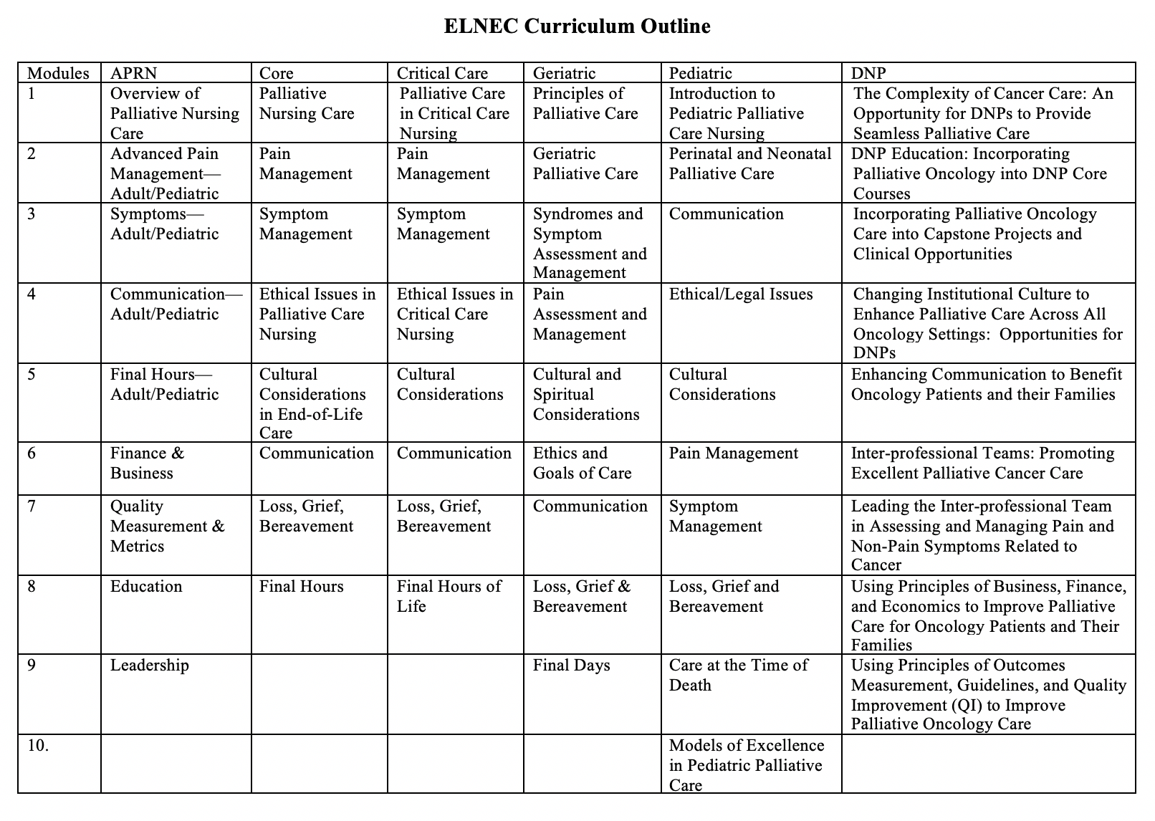

- Other palliative care nursing videos from ELNEC
https://jh.box.com/s/50x4on44069369aqrjbefqbhakmk2ufn
    - Transitioning to Hospice
    - Talking with a seriously ill young adult about pain management
    - Talking a symptom history nausea and vomiting
    - Pain management discussion
    - Having an advance care planning conversation
    - Assessing depression
    - ASK-TELL-ASK
    - Addressing professional conflict over goals of care
    - Active listening

- Center for Advanced Palliative Care
To create an account: https://www.capc.org/accounts/register/
For organization, select The Johns Hopkins Hospital- Baltimore, MD.
Then, after clicking continue, it asks for detail on the name, email address (we must provide the jhmi email address) and new password to access CAPC. Once the account is set up, access all the online courses.

- American Nurses Foundation:
Defining hope: Study guide videos
https://hope.film/study-guide-videos-full-version/?utm_source=Real%20Magnet&utm_medium=Em2&utm_campaign=Defining_Hope
14 Short videos with study guides to discuss a difficult topic

- The Initiative for Pediatric Palliative Care: Provides facilitator guides and video resources http://www.ippcweb.org/curriculum.htm
Module 1: Engaging with children and families
Module 2: Relieving pain and other symptoms
Module 3: Analyzing ethical challenges
Module 4: Responding to suffering and bereavement
Module 5: Improving communication and strengthening relationships

- Vision of Hope: Integration of palliative care in chronic pediatric disease
Johns Hopkins Berman Institute of Bioethics http://www.bioethicsinstitute.org/research/projects-2/hope#
* The vision of hope curriculum motivated by a commitment to integrate the principles of pediatric palliative care (PPC) into the care of individuals living with Sickle Cell Disease or Duchenne Muscular Dystrophy (DMD).

- Other Resources
- Candace Bertotti: The Art of Getting to Know Someone
https://www.youtube.com/watch?v=o5fGnuFB5gw
- Dr. Diane E. Meier: 10 Things to do for a Family Meeting
https://www.youtube.com/watch?v=7kQ3PUyhmPQ
- BJ Miller: What Really Matters
https://www.youtube.com/watch?v=apbSsILLh28
- Brené Brown
- Vulnerability: https://www.youtube.com/watch?v=iCvmsMzlF7o
- Shame: https://www.youtube.com/watch?v=psN1DORYYV0
- Sympathy Vs. Empathy: https://www.youtube.com/watch?v=1Evwgu369Jw
- TED Talk
https://www.ted.com/talks/nora_mcinerny_we_don_t_move_on_from_grief_we_move_forward_with_it
- Netflix
- End Game- (academy award nominee 2019)
- Extremis – (academy award nominee 2018)
- Books
- Being Mortal – Atul Gawande
- When Breath Becomes Air – Paul Kalanathi
- Four Things That Matter Most- Ira Byock
- A Beginner’s Guide to the End- Miller/Berger
- Rising Strong- Brene Brown

- Resources specific to COVID-19 and Palliative Care
- Center to Advance Palliative Care (CAPC): CAPC COVID-19 Response Resources
https://www.capc.org/toolkits/covid-19-response-resources/
- Hospice and Palliative Nurses Association (HPNA): Resources to Address Coronavirus Disease 2019 https://advancingexpertcare.org/covid-19-resources
- National Coalition for Hospice and Palliative Care: COVID-19 Resources
https://www.nationalcoalitionhpc.org/COVID19/
- National Hospice and Palliative Care Organization: Emergency Preparedness COVID-19 Information
https://www.nhpco.org/coronavirus
- VitalTalk: COVID-ready communication skills: A playbook of VitalTalk Tips
https://www.vitaltalk.org/guides/covid-19-communication-skills/
- ELNEC
https://www.aacnnursing.org/ELNEC/COVID-19

